Wasteland!
By: Domnik Amado-Tramondo, Kyle Lemons, Necolai Mcintosh, and David Nunez
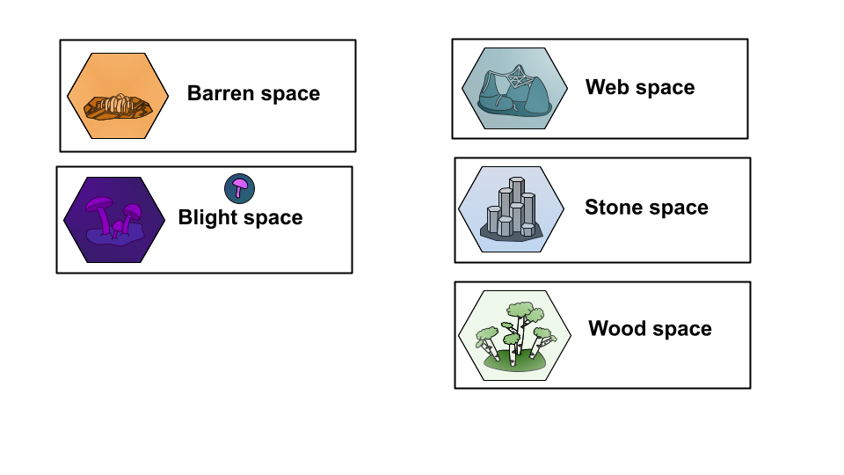
Piece List

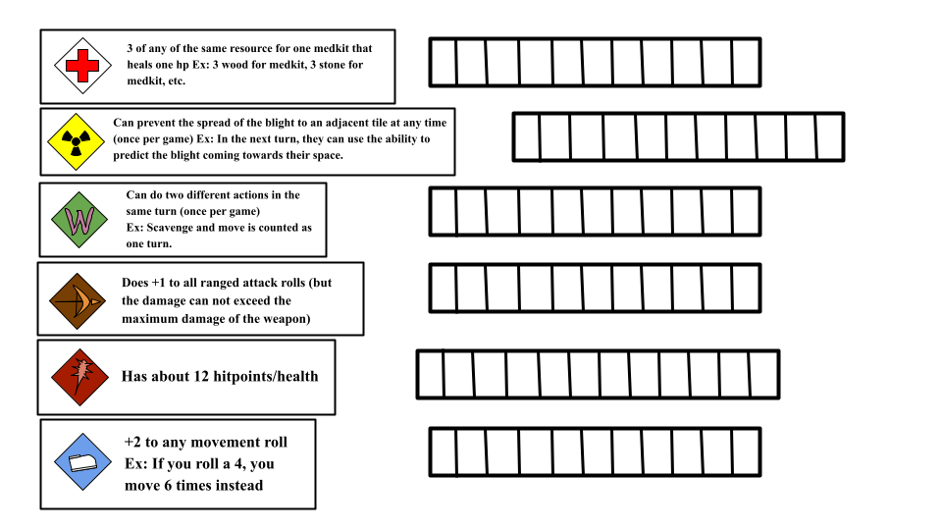

Setup
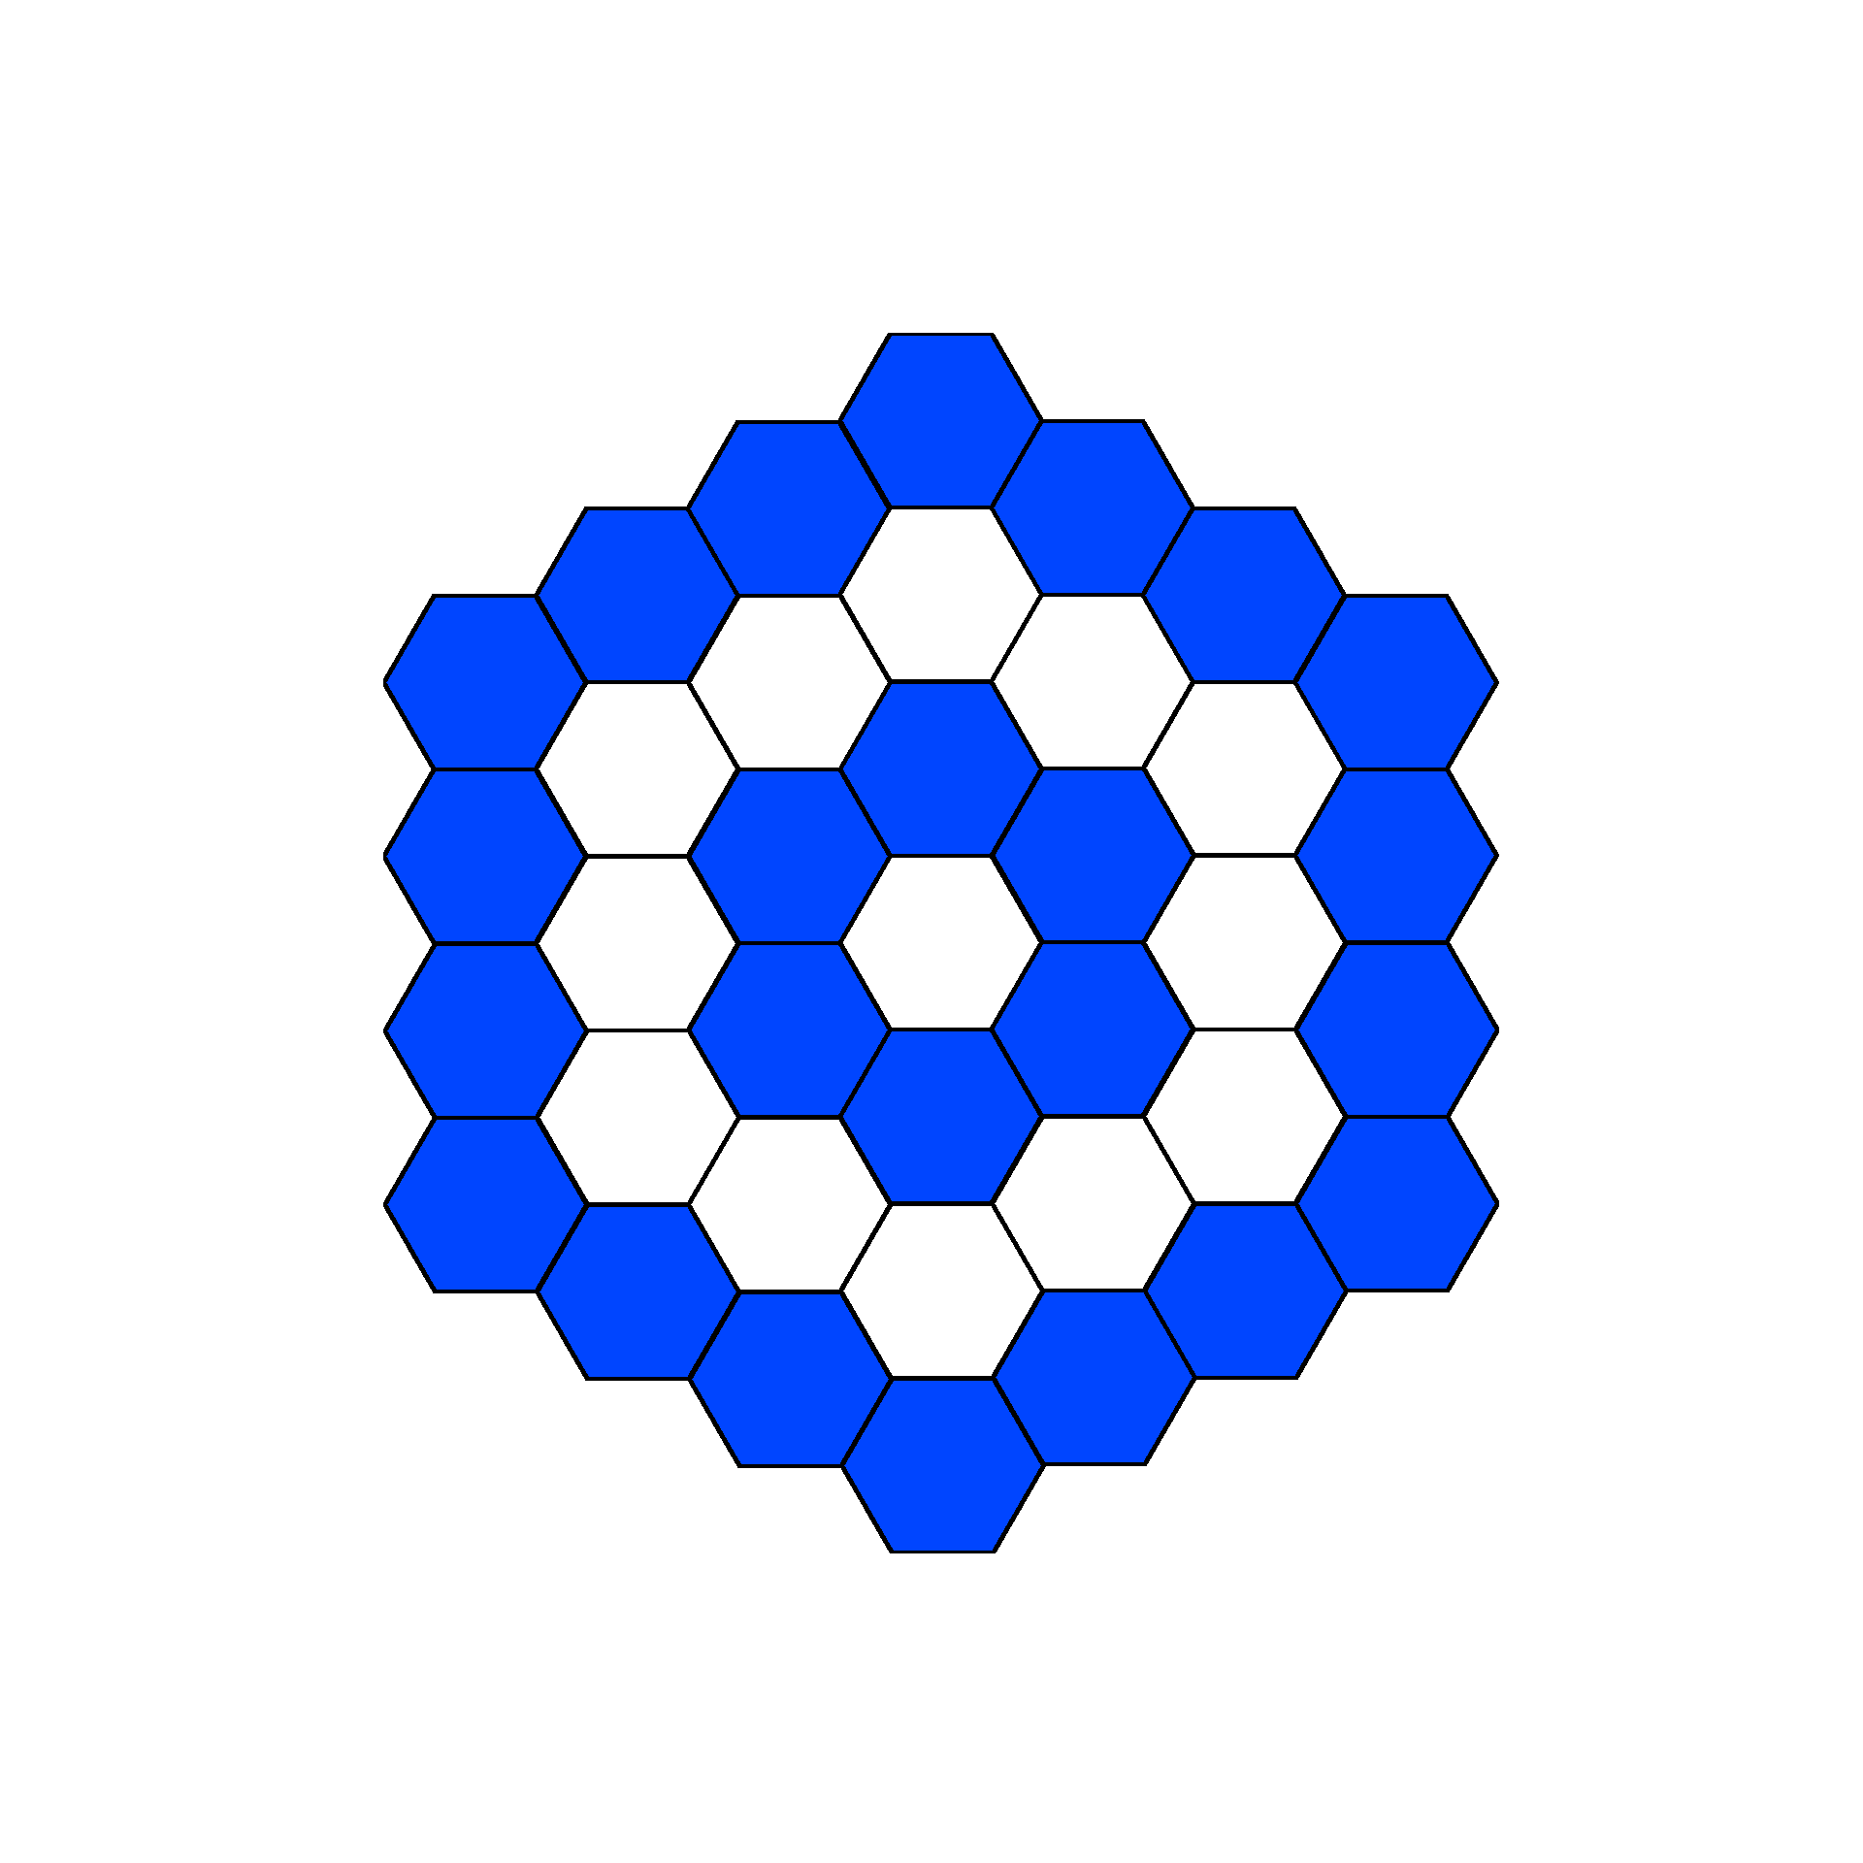
Randomly put all 37 tiles in a hexagon shaped pattern.
- There should be 3 hexagon “rings” around a center hexagon.
Randomly put number chips on every tile except the
Blight tiles.
Every player picks a character and places their
player piece on the board.
- Player pieces can not be placed on tiles with a
gold number chip or blight tiles.
- Player pieces can not be placed within 1 tile of
another player piece.
Each player gets with a resource card corresponding to
the tile that they start on. (e.g. if a player starts on a webbing tile,
that player gets a webbing resource card)
Each player starts with 10 health.
The player that is last alive wins the game.

Characters and Abilities
Wastelander (Green with W piece) - Can do 2 different actions in the same turn, once per game
Marksman (Brown with bow piece) - +1 to all damage rolls on ranged attacks, but the damage can not exceed the maximum damage of the weapon
Hazmat Person (Yellow with radiation symbol piece) - Can prevent the spread of the blight to any adjacent tile or their own tile at any time, once per game
Berserker (Red with club piece) - Starts the game with 12 health instead of the normal 10
Runner (Blue with shoe piece) - +2 to any of their own movement rolls, three times per game
Medic (White with red cross piece) - Special crafting recipe - 3 of any resource to make a makeshift medkit

Player Turns
Each player may move and perform 1 action per turn. Players may choose to move or perform an action in any order. (e.g. Player A may choose move then perform an action, and player B may choose to perform an action then move)
- Movement
  - Players roll a 4-sided die and may move across that many tiles
  - Players may “stop short” if they choose (e.g. if a player rolls a 4, the player may choose to stop after only moving across 2 tiles)
  - After a player stops their movement, they may not move until their next turn
  - After a player rolls to move, the player must move across at least 1 tile
- Actions
  - Scavenge
    - The player gets the resource card associated with the tile they are standing on
    - If a player is standing on a gold number chip tile, they may choose to draw an item card instead of a resource card
  - Attack
    - Player may attack another player with a declared weapon, or an unarmed attack
    - The attacking player rolls for damage and does that damage to the player they are attacking
  - Crafting
    - Players may craft by turning in resource cards and getting their desired crafted card

Blight Turns
Blight turns happen after the last player has finished their turn and before the first player starts their next turn.
- Draw a blight card and spread the blight accordingly with the blight chips
- Players may not gain resources from blighted tiles

Attacking
Melee attack range - Players must be on the same tile to attack another player with a melee weapon
Unarmed attack - Unarmed attack is a melee attack that does 1-2 damage
Crafting
Makeshift Medkit - Heals 1hp - 1 webbing, 1 wood, 1 stone
Makeshift Weapon - Deals 2-3 damage - 2 wood, 1 stone
Makeshift Bow - Deals 1-2 damage (-1 per tile distance) also requires 1 arrow per shot - 2 wood, 1 webbing
Makeshift Arrow - Required for the bow to shoot - 1 wood, 1 stone

Special Effects, Conditions, and Miscellaneous Rules
Death - If a player dies to another player’s attack in melee range the player that killed the other player may take one item card from the dead player’s hand and discard the rest. If a player dies to the environment or dies to a player outside of melee range, all the dead player’s cards are discarded.
Blight - If a player ends their turn on a blighted tile, they take 1 damage.
Cleanse - Cleanses last until the beginning of the cleansing player’s next turn. After a cleanse ends, blight returns to the cleansed tile.
Blight prevention - If a player prevents the blight from spreading to a tile, the tile does not become blighted after the prevention ends.
Fire - Players that are on a tile when it is set on fire take 1 damage. Players that cross through tiles on fire take 1 damage. Players that end their turn on tiles on fire take 1 damage.
Trading - Players may trade any number of cards with each other, but players can only trade cards with other players they are standing on the same tile as. Trading does not count as an action.
Item cards - Players may only use item cards on their turn unless otherwise stated
Backpack - Players can only hold up to 7 cards in their hand. If they pick up another card, they may choose to discard any card in their hand for the new card or choose to not pick up the new card.

